**Replace Implementation Inheritance With Composition**

|  |  |  |
| --- | --- | --- |
| *a class is being subclassed for implementation purposes* |  | *replace the inheritance relationship with composition, thereby preserving encapsulation* |

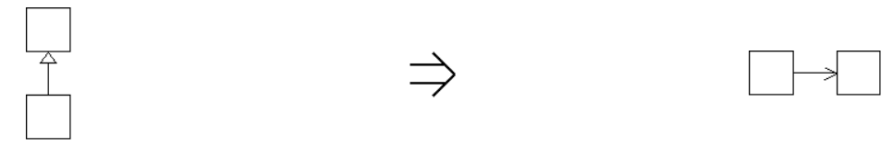

**Context:**  
See also :[Replace Specializing Composition With Inheritance](https://web.archive.org/web/20090212002921/http:/www.refactoring.be/thumbnails/rtn-rscwi.html),*Replace Delegation With Inheritance[Fowler]*